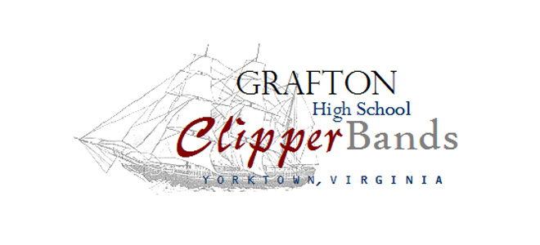

Wind Ensemble Parents:

I am writing to you to tell you about an exciting opportunity for your students on Monday, Feb. 27. The Music Dept. at the University of Virginia has invited the wind ensemble onto the grounds at UVA for a day to work with the music faculty at UVA on our assessment music in clinic type setting. They will be working for 3-4 hours with the band as a group and possibly in sectionals, eating lunch, and touring the UVA grounds with students from the UVA music dept. as a part of this trip.

UVA is not charging us for the clinic, however we will have to incur the expense of getting to UVA on a charter bus. The band parents have graciously agreed to pay for a charter bus. There is one small catch—the bus has 55 seats and we have 59 students in the wind ensemble. We hope to secure a couple of band parents to drive to UVA behind the bus to free up enough seats that the band can fit on one bus so we can keep expenses down. The band parents are willing to reimburse you for your gas on the trip.

We would likely leave Grafton around 6:30am and return somewhere around 5:00. The exact schedule has not been set at this point. If you are interested and willing to drive on Monday, Feb. 27 please let me know ASAP at dkirsch@ycsd.york.va.us

As always, we are excited about this opportunity for our kids and we appreciate your support.

Darren Kirsch

403 Grafton Drive ~ Yorktown, Va 23692
dkirsch@ycsd.york.va.us

